s1739768

**DAH Checkpoint 2 Document**

***1. Explain what all connections to the ADC chip are for (do not simply copy information from the datasheet — explain the practical purpose of these connections).***

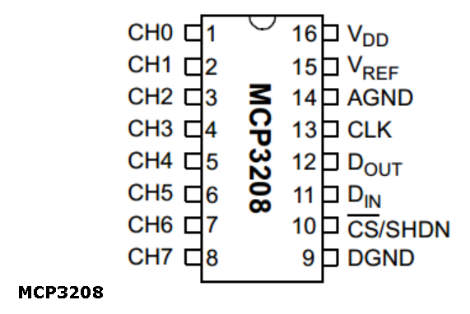

* Pins 1-8 (CH0-CH7) are analogue input channels to read in voltage at a point between a potential divider for example.
* Pin 16 (VDD) is the connection to a power supply between +2.7V to 5.5V to power the ADC
* Pin 15 (VREF) connects with a reference voltage to assign the highest binary output (4096) to
* Pin 14 (AGND) is the analogue ground connection, to ground internal analogue circuitry
* Pin 13 (CLK) is the clock pin which synchronises both sides of data being sent and received so the receiver sees the correct bits without the need for designated start and stop bits
* Pin 12 (DOUT) is the SPI serial data output pin and changes on the falling edge of each clock pulse
* Pin 11 (DIN) is the SPI serial data input pin
* Pin 10 (CS/SHDN) is the chip select/shutdown pin and when it is set high, makes all other pins ignore changes sent to them allowing the other pins to remain connected but not be in use
* Pin 9 (DGND) is the digital ground connection, to ground internal digital circuitry

***2. Explain the meaning of the return values of each Python method for the ADC.***

* ADC0. analogCount () returns the number of analogue channels (8 for MCP3208)
* ADC0. analogResolution () returns the analogue resolution/bit count (12 for MCP3208)
* ADC0. analogMaximum () returns the maximum analogue integer value for converting a voltage input to binary number based on reference voltage (4096 for MCP3208)
* ADC0. analogReference () returns the voltage corresponding to the maximum analogue integer (reference voltage)
* ADC0. analogRead ( channel ) returns the integer value of the given analogue channel as converted from the voltage (see next question)
* ADC0. analogReadFloat ( channel ) returns the float value of the given analogue channel (the integer value over the maximum 4096)
* ADC0. analogReadVolt ( channel ) returns the voltage value of the given analogue
* ADC0. analogReadAll () returns a list of all channels’ integer values
* ADC0. analogReadAllFloat () returns a list of all channels’ float values
* ADC0. analogReadAllVolt () returns a list of all channels’ voltages

***3. What is the primary (most fundamental) ADC output and how is the final voltage output calculated from this?***

The ADC outputs an integer from 0 to 212 = 4096 for 12 bit MCP3208 from the voltage it reads in based on the following calculation:

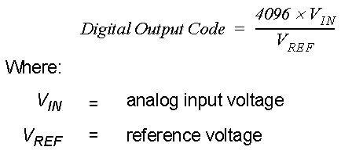

It returns an integer which is in the same ratio to 4096 as the voltage read in is to the reference voltage.

***4. Explain how the ADC readings change when you cover the LDR with your hand— you may need to provide a circuit diagram.***

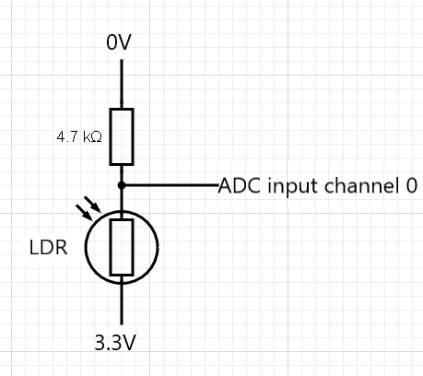

Resistance of LRD drops as the light intensity hitting it drops (from being covered by hand). The LRD is in a potential divider circuit with the resistor. The current increases due to the drop in total resistance of both components in series added. The voltage across the resistor increases as its resistance is unchanged. This is read by the ADC channel 0 as the other side of the resistor is connected to ground so the ADC reading increases.

***5. Explain what all the connections to the DAC chip are for.***

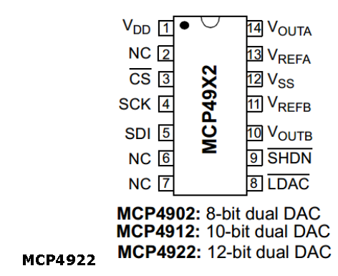

* Pin 1 (VDD) is the connection to a power supply between +2.7V to 5.5V to power the DAC
* Pin 2 (NC) is no connection
* Pin 3 (CS) is the chip select pin ???
* Pin 4 (SCK) is the serial clock input which synchronises both sides of data being sent and received so the receiver sees the correct bits without the need for designated start and stop bits
* Pin 5 (SDI) is the serial data input pin
* Pin 6 (NC) is no connection
* Pin 7 (NC) is no connection
* Pin 14 (VOUTA) is the DAC A output pin and can carry a voltage from VSS to VDD
* Pin 13 (VREFA) is the voltage reference input for DAC channel A used in the conversion calculation
* Pin 12 (VSS) is the analogue ground pin
* Pin 11 (VREFB) is the voltage reference input for DAC channel B used in the conversion calculation
* Pin 10 (VOUTB)) is the DAC A output pin and can carry a voltage from VSS to VDD
* Pin 9 (nSHDN) shuts down the DAC channels when set to low
* Pin 8 (nLDAC) is the latch DAC input pin ???